Web Programming Lab - Week 2

Name: Srihari Srinivasan

Date: 14/01/2025

Section: C Roll No: 40

Registration Number: 220905326

1. Write a web page which contains table with 3 X 3 dimensions (fill some data) and one

image. Style the rows with alternate color. Move the table and image together from

right to left when button is clicked.

**HTML:**

<!DOCTYPE html>

<html>

<head>

<title> Moving Table </title>

<script type="text/javascript" src="jquery-3.4.1.js"> </script>

<script type="text/javascript">

$(document).ready(function() {

$("table").css({"border": "1px solid black", "border-collapse": "collapse", "padding": "3px"});

$("th").css({"border": "1px solid black", "border-collapse": "collapse", "padding": "3px"});

$("td").css({"border": "1px solid black", "border-collapse": "collapse", "padding": "3px"});

$(".even").css({"background": "lightgreen"});

$(".odd").css({"background": "lightblue"});

$("button").click(function() {

$(".body-div").css({"float": "right", "margin-right": "auto"});

});

});

</script>

</head>

<body>

<div class="body-div">

<table class="mytable">

<thead>

<th>Head 1</th>

<th>Head 2</th>

<th>Head 3</th>

</thead>

<tbody>

<tr class="even">

<td>Data 11</td>

<td>Data 12</td>

<td>Data 13</td>

</tr>

<tr class="odd">

<td>Data 21</td>

<td>Data 22</td>

<td>Data 23</td>

</tr>

<tr class="even">

<td>Data 21</td>

<td>Data 22</td>

<td>Data 23</td>

</tr>

</tbody>

</table>

<br/>

<img src="img1.jpeg" alt="Car image">

<br/>

<button id="mybutton">Click me to move</button>

</div>

</body>

</html>

**OUTPUT:**

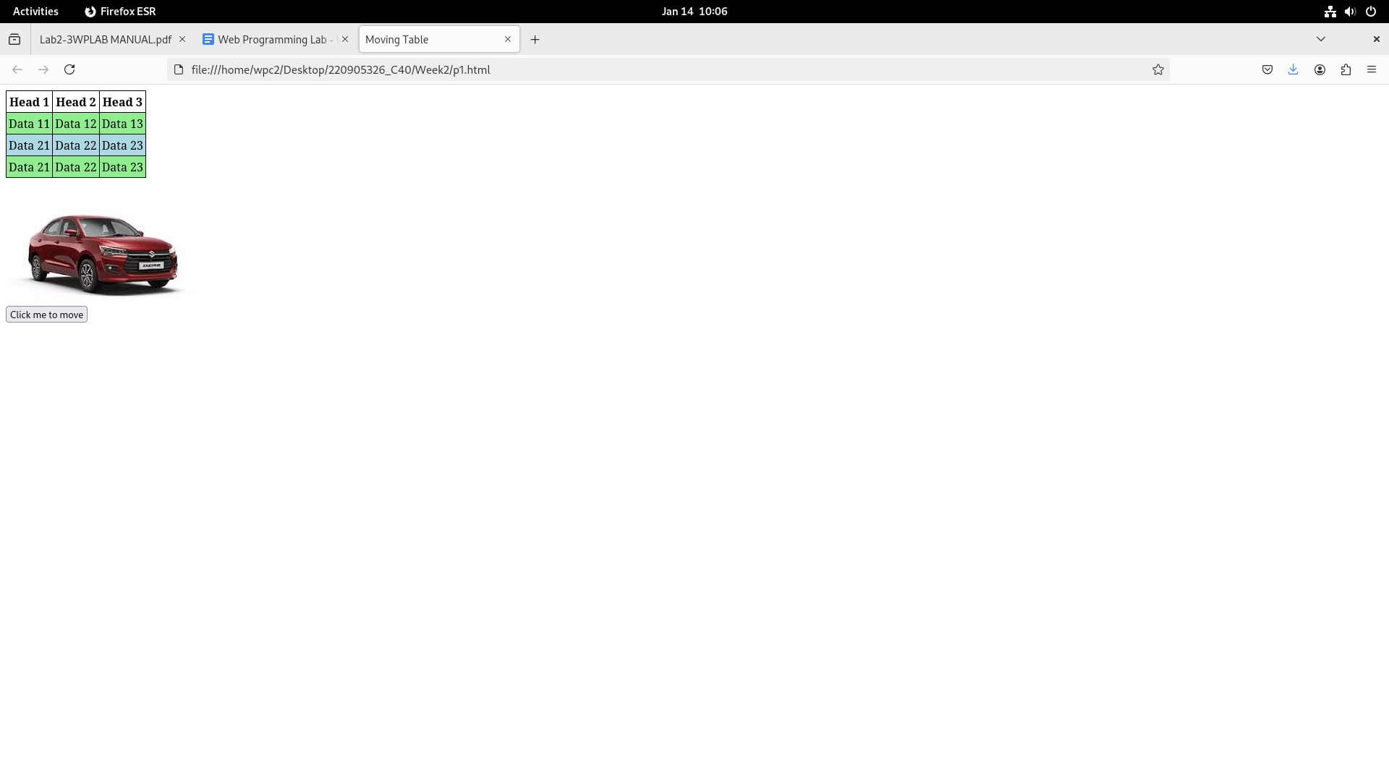

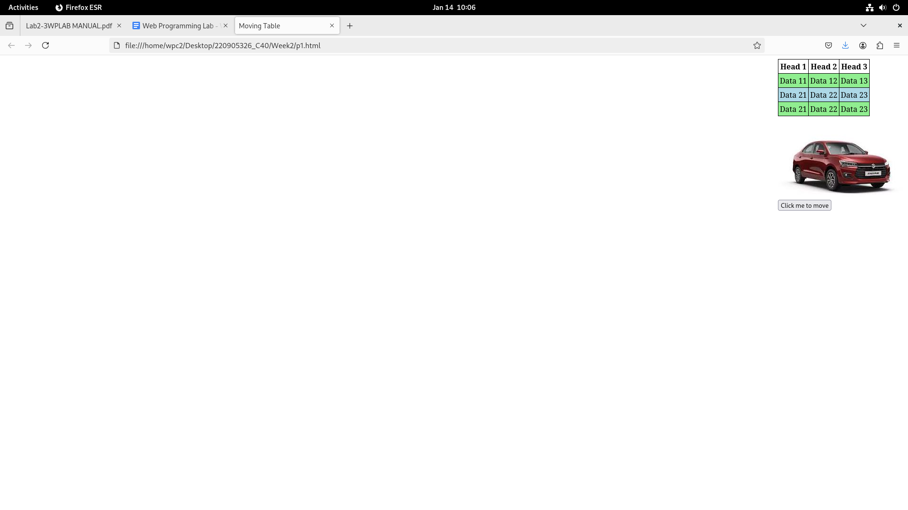

1. Design a calculator to perform basic arithmetic operations. Use textboxes and buttons

to design web page.

**HTML:**

<!DOCTYPE html>

<html>

<head>

<title>Basic Calculator</title>

<script type="text/javascript" src="jquery-3.4.1.js"> </script>

<script type="text/javascript">

$(document).ready(function() {

$('.button').css({"margin": "5px 5px 5px 5px"});

// for all buttons that are not clear or equal

$('.button').not('.clear').not('.equals').click(function() {

// get number value

var value = $(this).data('value');

// pure append

$('#display').val($('#display').val() + value);

});

$('.clear').click(function() {

$('#display').val('');

});

$('.equals').click(function() {

try {

var result = eval($('#display').val());

$('#display').val(result);

} catch (e) {

$('#display').val('Error');

}

});

});

</script>

</head>

<body>

<div>

<input type="text" id="display" disabled>

</div>

<div>

<button class="button" data-value="7">7</button>

<button class="button" data-value="8">8</button>

<button class="button" data-value="9">9</button>

<button class="button operator" data-value="+">+</button>

</div>

<div>

<button class="button" data-value="4">4</button>

<button class="button" data-value="5">5</button>

<button class="button" data-value="6">6</button>

<button class="button operator" data-value="-">-</button>

</div>

<div>

<button class="button" data-value="1">1</button>

<button class="button" data-value="2">2</button>

<button class="button" data-value="3">3</button>

<button class="button operator" data-value="*">*</button>

</div>

<div>

<button class="button" data-value="0">0</button>

<button class="button clear">C</button>

<button class="button equals">=</button>

<button class="button operator" data-value="/">/</button>

</div>

</body>

</html>

**OUTPUT:**

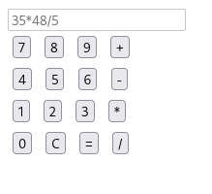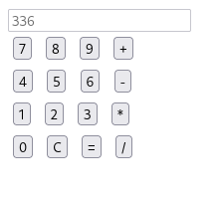

1. Create a web page to design a birthday card shown below

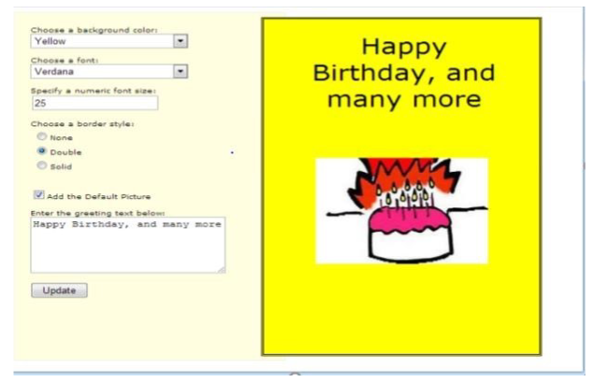

**HTML:**

<!DOCTYPE html>

<html>

<head>

<title>Birthday Card Generator</title>

<script type="text/javascript" src="jquery-3.4.1.js"></script>

<style>

body {

display: flex;

justify-content: space-between;

padding: 20px;

font-family: Arial, sans-serif;

}

.body-div {

width: 45%;

padding: 20px;

}

.left {

background-color: lightyellow;

}

.right {

background-color: yellow;

text-align: center;

padding: 20px;

border: none;

position: relative;

}

#card-image {

margin-top: 20px;

max-width: 100%; /* Ensures the image fits within the container's width */

max-height: 300px; /* Limits the image height */

height: auto; /* Maintains aspect ratio */

display: block; /* Centers the image */

margin-left: auto;

margin-right: auto;

}

</style>

<script type="text/javascript">

$(document).ready(function () {

$("#apply-button").click(function () {

// Get the selected background color

var bgColor = $("#color-selector").val();

$(".right").css("background-color", bgColor);

// Get the selected font family

var font = $("#font-selector").val();

$(".right").css("font-family", font);

// Get the font size

var fontSize = $("#font-size-choice").val() + "px";

$(".right").css("font-size", fontSize);

// Get the border style

var borderStyle = $(

"input[name='border-style']:checked"

).val();

$(".right").css(

"border",

borderStyle === "none"

? "none"

: `5px ${borderStyle} black`

);

// Check if the default image checkbox is checked

if ($("#default-image-checkbox").is(":checked")) {

if ($("#card-image").length === 0) {

$(".right").append(

'<img id="card-image" src="img.jpg" alt="Birthday Cake">'

);

}

} else {

$("#card-image").remove();

}

// Set the greeting text

var greetingText = $("#greeting-text").val();

$("#greeting-display").text(greetingText);

});

});

</script>

</head>

<body>

<div class="left body-div">

<label

>Choose a background color:

<select id="color-selector">

<option value="red">Red</option>

<option value="blue">Blue</option>

<option value="green">Green</option>

<option value="orange">Orange</option>

<option value="lightblue">Light Blue</option>

<option value="yellow" selected>Yellow</option>

</select>

</label>

<br /><br />

<label

>Choose a font:

<select id="font-selector">

<option value="Verdana" selected>Verdana</option>

<option value="Arial">Arial</option>

<option value="Georgia">Georgia</option>

<option value="Comic Sans MS">Comic Sans MS</option>

</select>

</label>

<br /><br />

<label

>Specify font size:

<input id="font-size-choice" type="number" value="25" />

</label>

<br /><br />

<label

>Choose border style:

<label

><input

id="border-style-none"

type="radio"

name="border-style"

value="none"

checked

/>

None</label

>

<label

><input

id="border-style-double"

type="radio"

name="border-style"

value="double"

/>

Double</label

>

<label

><input

id="border-style-solid"

type="radio"

name="border-style"

value="solid"

/>

Solid</label

>

</label>

<br /><br />

<label

><input type="checkbox" id="default-image-checkbox" /> Add

Default Image</label

>

<br /><br />

<label>Enter the greeting text below:</label>

<textarea id="greeting-text" rows="4" cols="30">

Happy Birthday, and many more</textarea

>

<br /><br />

<button id="apply-button">Apply Changes</button>

</div>

<div class="right body-div">

<div

id="greeting-display"

style="font-size: 25px; font-family: Verdana"

>

Happy Birthday, and many more

</div>

<img

id="card-image"

src="img.jpg"

alt="Birthday Cake"

style="display: none"

/>

</div>

</body>

</html>

**OUTPUT:**

